**Regression is a statistical technique that helps to find relationships between a dependent variable (Y) and multiple independent (X) variables. Here, the independent variables are known as the predictors or explanatory variables, and the dependent variable is referred to as a response or target variable.**

Regression analysis is a type of predictive modeling technique which is used to find the relationship between a dependent variable (usually known as the “Y” variable) and either one independent variable (the “X” variable) or a series of independent variables. When two or more independent variables are used to predict or explain the outcome of the dependent variable, this is known as multiple regression.

Regression analysis can be used for three things:

1. Forecasting the effects or impact of specific changes. For example, if a manufacturing company wants to forecast how many units of a particular product they need to produce in order to meet the current demand.
2. Forecasting trends and future values. For example, how much will the stock price of  Lufthansa be in 6 months from now?
3. Determining the strength of different predictors—or, in other words, assessing how much of an impact the independent variable(s) has on a dependent variable. For example, if a soft drinks company is sponsoring a football match, they might want to determine if the ads being displayed during the match have accounted for any increase in sales.

Regression analysis can be broadly classified into two types: Linear regression and logistic regression.

In statistics, linear regression is usually used for predictive analysis. It essentially determines the extent to which there is a linear relationship between a dependent variable and one or more independent variables. In terms of output, linear regression will give you a trend line plotted amongst a set of data points. You might use linear regression if you wanted to predict the sales of a company based on the cost spent on online advertisements, or if you wanted to see how the change in the GDP might affect the stock price of a company.

**T**he second type of regression analysis is logistic regression, and that’s what we’ll be focusing on in this post. Logistic regression is essentially used to calculate (or predict) the probability of a binary (yes/no) event occurring.

**Linear Regression:**

**Linear Regression** is the supervised Machine Learning model in which the **model finds the best fit linear line between the independent and dependent variable** i.e it finds the linear relationship between the dependent and independent variable.

Linear Regression is of two types: **Simple and Multiple**. **Simple Linear Regression** is where only one independent variable is present and the model has to find the linear relationship of it with the dependent variable

Whereas, In **Multiple Linear Regression** there are more than one independent variables for the model to find the relationship.

Equation of Simple Linear Regression, where bo is the intercept, b1 is coefficient or slope, x is the independent variable and y is the dependent variable.



Equation of Multiple Linear Regression, where bo is the intercept, b1,b2,b3,b4…,bn are coefficients or slopes of the independent variables x1,x2,x3,x4…,xn and y is the dependent variable.



**A Linear Regression model’s main aim is to find the best fit linear line and the optimal values of intercept and coefficients such that the error is minimized.**Error is the difference between the actual value and Predicted value and the goal is to reduce this difference.

Let’s understand this with the help of a diagram.

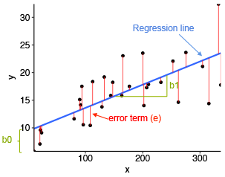

Image Source: Statistical tools for high-throughput data analysis

In the above diagram,

* x is our dependent variable which is plotted on the x-axis and y is the dependent variable which is plotted on the y-axis.
* Black dots are the data points i.e the actual values.
* bo is the intercept which is 10 and b1 is the slope of the x variable.
* The blue line is the best fit line predicted by the model i.e the predicted values lie on the blue line.

**The vertical distance between the data point and the regression line is known as error or residual.** Each data point has one residual and the sum of all the differences is known as **he Sum of Residuals/Errors.**

**Mathematical Approach:**

Residual/Error = Actual values – Predicted Values

Sum of Residuals/Errors = Sum(Actual- Predicted Values)

Square of Sum of Residuals/Errors = (Sum(Actual- Predicted Values))2

i.e



## **Assumptions of Linear Regression**

The basic assumptions of Linear Regression are as follows:

**1. Linearity**: It states that the dependent variable Y should be linearly related to independent variables. This assumption can be checked by plotting a scatter plot between both variables.

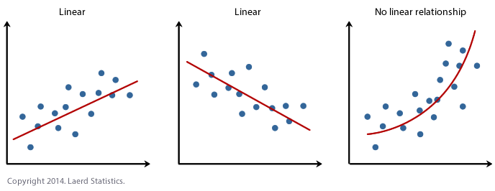

**2. Normality**: The X and Y variables should be normally distributed. Histograms, KDE plots, Q-Q plots can be used to check the Normality assumption.

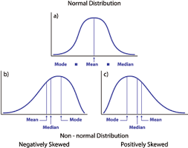

**3. Homoscedasticity**: The variance of the error terms should be constant i.e the spread of residuals should be constant for all values of X. This assumption can be checked by plotting a residual plot. If the assumption is violated then the points will form a funnel shape otherwise they will be constant.

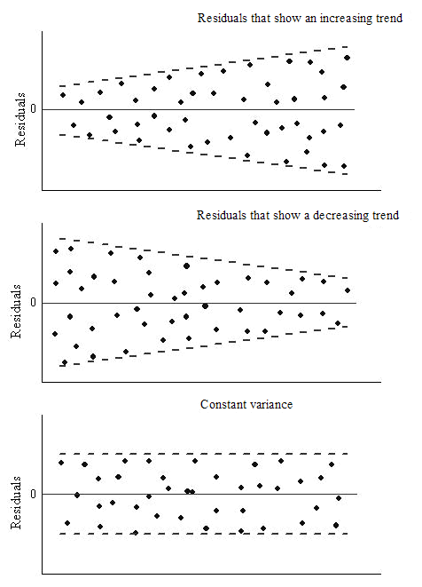

Source: OriginLab

**4. Independence/No Multicollinearity**: The variables should be independent of each other i.e no correlation should be there between the independent variables. To check the assumption, we can use a correlation matrix or VIF score. If the VIF score is greater than 5 then the variables are highly correlated.

In the below image, a high correlation is present between x5 and x6 variables.

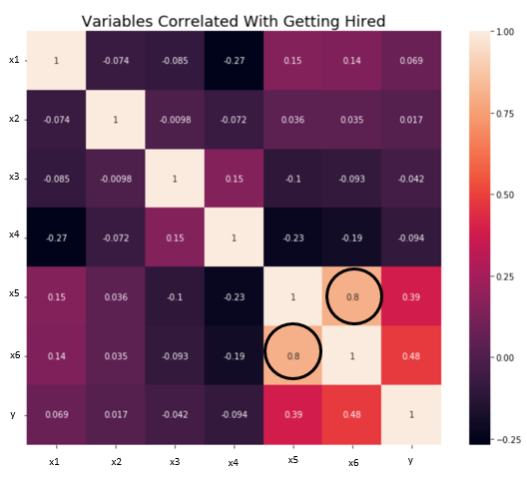

**5.** The **error terms should be normally distributed**. Q-Q plots and Histograms can be used to check the distribution of error terms.

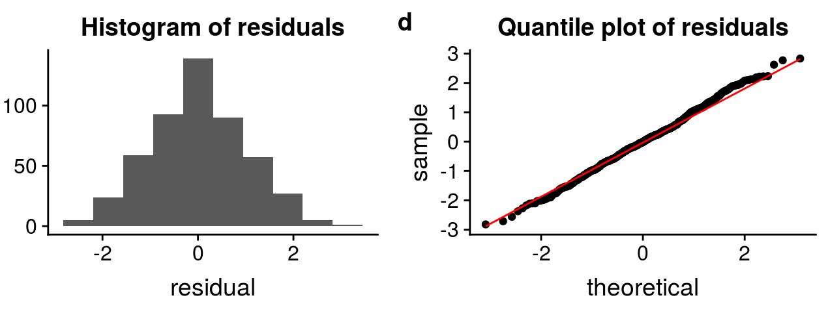

**6. No Autocorrelation:**The error terms should be independent of each other. Autocorrelation can be tested using the Durbin Watson test. The null hypothesis assumes that there is no autocorrelation. The value of the test lies between 0 to 4. If the value of the test is 2 then there is no autocorrelation.

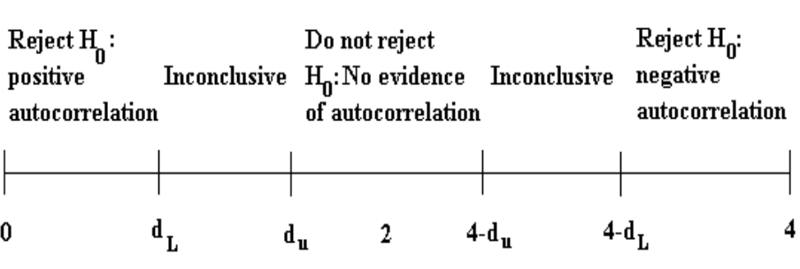

## **How to deal with the Violation of any of the Assumption**

The Violation of the assumptions leads to a decrease in the accuracy of the model therefore the predictions are not accurate and error is also high.  
**For example,** if the Independence assumption is violated then the relationship between the independent and dependent variable can not be determined precisely.

There are various methods are techniques available to deal with the violation of the assumptions. Let’s discuss some of them below.

**Violation of Normality assumption of variables or error terms**

To treat this problem, we can transform the variables to the normal distribution using various transformation functions such as log transformation, Reciprocal, or Box-Cox Transformation.

**Violation of MultiCollineraity Assumption**

It can be dealt with by:

* Doing nothing (if there is no major difference in the accuracy)
* Removing some of the highly correlated independent variables.
* Deriving a new feature by linearly combining the independent variables, such as adding them together or performing some mathematical operation.
* Performing an analysis designed for highly correlated variables, such as principal components analysis.

## **Evaluation Metrics for Regression Analysis**

To understand the performance of the Regression model performing model evaluation is necessary. Some of the Evaluation metrics used for Regression analysis are:

1. **R squared or Coefficient of Determination:** The most commonly used metric for model evaluation in regression analysis is R squared. It can be defined as a Ratio of variation to the Total Variation. The value of R squared lies between 0 to 1, the value closer to 1 the better the model.

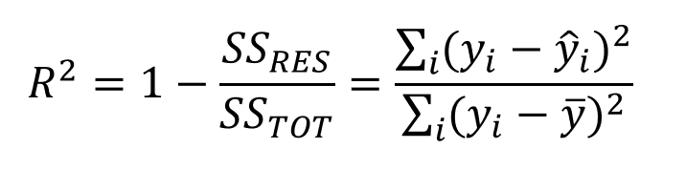

where SSRES is the Residual Sum of squares and SSTOT is the Total Sum of squares

2. **Adjusted R squared:** It is the improvement to R squared. The problem/drawback with R2 is that as the features increase, the value of R2 also increases which gives the illusion of a good model. So the Adjusted R2 solves the drawback of R2. It only considers the features which are important for the model and shows the real improvement of the model.  
Adjusted R2 is always lower than R2.

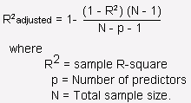

3. **Mean Squared Error (MSE)**: Another Common metric for evaluation is Mean squared error which is the mean of the squared difference of actual vs predicted values.

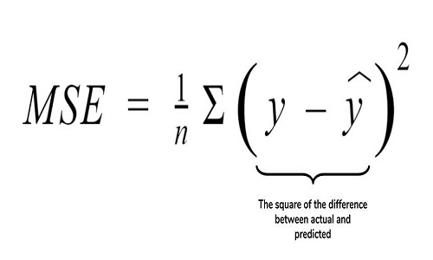

4. **Root Mean Squared Error (RMSE)**: It is the root of MSE i.e Root of the mean difference of Actual and Predicted values. RMSE penalizes the large errors whereas MSE doesn’t.

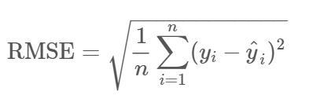

Logistic regression

This type of statistical analysis (also known as logit model) is often used for predictive analytics and modeling, and extends to applications in machine learning. In this analytics approach, the dependent variable is finite or categorical: either A or B (binary regression) or a range of finite options A, B, C or D (multinomial regression). It is used in statistical software to understand the relationship between the dependent variable and one or more independent variables by estimating probabilities using a logistic regression equation.

Logistic regression is a type of regression analysis. So, before we delve into logistic regression, let us first introduce the general concept of regression analysis.

## 2. What is logistic regression?

Logistic regression is a classification algorithm. It is used to predict a binary outcome based on a set of independent variables.

Ok, so what does this mean? A binary outcome is one where there are only two possible scenarios—either the event happens (1) or it does not happen (0). Independent variables are those variables or factors which may influence the outcome (or dependent variable).

So: Logistic regression is the correct type of analysis to use when you’re working with binary data. You know you’re dealing with binary data when the output or dependent variable is dichotomous or categorical in nature; in other words, if it fits into one of two categories (such as “yes” or “no”, “pass” or “fail”, and so on).

However, the independent variables can fall into any of the following categories:

1. Continuous—such as temperature in degrees Celsius or weight in grams. In technical terms, continuous data is categorized as either [**interval data**](https://careerfoundry.com/en/blog/data-analytics/what-is-interval-data/), where the intervals between each value are equally split, or [**ratio data**](https://careerfoundry.com/en/blog/data-analytics/what-is-ratio-data/), where the intervals are equally split and there is a true or meaningful “zero”. For example, temperature in degrees Celsius would be classified as interval data; the difference between 10 and 11 degrees C is equal to the difference between 30 and 31 degrees C, but there is no true zero—a temperature of zero degrees does not mean there is “no temperature”. On the other hand, weight in grams would be classified as ratio data; it has the equal intervals and a true zero. In other words, if something weighs zero grams, it truly weighs nothing.
2. Discrete, ordinal—that is, data which can be placed into some kind of order on a scale. For example, if you are asked to state how happy you are on a scale of 1-5, the points on the scale represent ordinal data. A score of 1 indicates a lower degree of happiness than a score of 5, but there is no way of determining the numerical value between each of the points on the scale. Ordinal data is the kind of data you might get from a customer satisfaction survey.
3. Discrete, nominal—that is, data which fits into named groups which do not represent any kind of order or scale. For example, eye color may fit into the categories “blue”, “brown”, or “green”, but there is no hierarchy to these categories.

So, in order to determine if logistic regression is the correct type of analysis to use, ask yourself the following:

* Is the dependent variable dichotomous? In other words, does it fit into one of two set categories? Remember: The dependent variable is the outcome; the thing that you’re measuring or predicting.
* Are the independent variables either interval, ratio, or ordinal? See the examples above for a reminder of what these terms mean. Remember: The independent variables are those which may impact, or be used to predict, the outcome.

In addition to the two criteria mentioned above, there are some further requirements that must be met in order to correctly use logistic regression. These requirements are known as “assumptions”; in other words, when conducting logistic regression, you’re assuming that these criteria have been met. Let’s take a look at those now.

## 3. Logistic regression assumptions

* The dependent variable is binary or dichotomous—i.e. It fits into one of two clear-cut categories. This applies to binary logistic regression, which is the type of logistic regression we’ve discussed so far. We’ll explore some other types of logistic regression in section five.
* There should be no, or very little, multicollinearity between the predictor variables—in other words, the predictor variables (or the independent variables) should be independent of each other. This means that there should not be a high correlation between the independent variables. In statistics, certain tests can be used to calculate the correlation between the predictor variables; if you’re interested in learning more about those, just search “Spearman’s rank correlation coefficient” or “the Pearson correlation coefficient.”
* The independent variables should be linearly related to the log odds. If you’re not familiar with log odds, we’ve included a brief explanation below.
* Logistic regression requires fairly large sample sizes—the larger the sample size, the more reliable (and powerful) you can expect the results of your analysis to be.

### What are log odds?

In very simplistic terms, log odds are an alternate way of expressing probabilities. In order to understand log odds, it’s important to understand a key difference between odds and probabilities: odds are the ratio of something happening to something not happening, while probability is the ratio of something happening to everything that could possibly happen.

For example: if you and your friend play ten games of tennis, and you win four out of ten games, the odds of you winning are 4 to 6 ( or, as a fraction, 4/6). The probability of you winning, however, is 4 to 10 (as there were ten games played in total). As we can see, odds essentially describes the ratio of success to the ratio of failure. In logistic regression, every probability or possible outcome of the dependent variable can be converted into log odds by finding the odds ratio. The log odds logarithm (otherwise known as the logit function) uses a certain formula to make the conversion.

## 4. What is logistic regression used for?

Now we know, in theory, what logistic regression is—but what kinds of real-world scenarios can it be applied to? Why is it useful?

Logistic regression is used to calculate the probability of a binary event occurring, and to deal with issues of classification. For example, predicting if an incoming email is spam or not spam, or predicting if a credit card transaction is fraudulent or not fraudulent. In a medical context, logistic regression may be used to predict whether a tumor is benign or malignant. In marketing, it may be used to predict if a given user (or group of users) will buy a certain product or not. An online education company might use logistic regression to predict whether a student will complete their course on time or not.

As you can see, logistic regression is used to predict the likelihood of all kinds of “yes” or “no” outcomes. By predicting such outcomes, logistic regression helps [data analysts](https://careerfoundry.com/en/blog/data-analytics/difference-between-data-scientist-and-data-analyst/) (and the companies they work for) to make informed decisions. In the grand scheme of things, this helps to both minimize the risk of loss and to optimize spending in order to maximize profits. And that’s what every company wants, right?

For example, it wouldn’t make good business sense for a credit card company to issue a credit card to every single person who applies for one. They need some kind of method or model to work out, or predict, whether or not a given customer will default on their payments. The two possible outcomes, “will default” or “will not default”, comprise binary data—making this an ideal use-case for logistic regression. Based on what category the customer falls into, the credit card company can quickly assess who might be a good candidate for a credit card and who might not be.

Similarly, a cosmetics company might want to determine whether a certain customer is likely to respond positively to a promotional 2-for-1 offer on their skincare range. In which case, they may use logistic regression to devise a model which predicts whether the customer will be a “responder” or a “non-responder.” Based on these insights, they’ll then have a better idea of where to focus their marketing efforts.

## 5. What are the different types of logistic regression?

In this post, we’ve focused on just one type of logistic regression—the type where there are only two possible outcomes or categories (otherwise known as binary regression). In fact, there are three different types of logistic regression, including the one we’re now familiar with.

The three types of logistic regression are:

1. Binary logistic regression is the statistical technique used to predict the relationship between the dependent variable (Y) and the independent variable (X), where the dependent variable is binary in nature. For example, the output can be Success/Failure,  0/1 , True/False, or Yes/No. This is the type of logistic regression that we’ve been focusing on in this post.
2. Multinomial logistic regression is used when you have one categorical dependent variable with two or more unordered levels (i.e two or more discrete outcomes). It is very similar to logistic regression except that here you can have more than two possible outcomes. For example, let’s imagine that you want to predict what will be the most-used transportation type in the year 2030. The transport type will be the dependent variable, with possible outputs of train, bus, tram, and bike (for example).
3. Ordinal logistic regression is used when the dependent variable (Y) is ordered (i.e., ordinal). The dependent variable has a meaningful order and more than two categories or levels. Examples of such variables might be t-shirt size (XS/S/M/L/XL), answers on an opinion poll (Agree/Disagree/Neutral), or scores on a test (Poor/Average/Good).

## 6. What are the advantages and disadvantages of using logistic regression?

By now, you hopefully have a much clearer idea of what logistic regression is and the kinds of scenarios it can be used for. Now let’s consider some of the advantages and disadvantages of this type of regression analysis.

### Advantages of logistic regression

* Logistic regression is much easier to implement than other methods, especially in the context of machine learning: A machine learning model can be described as a mathematical depiction of a real-world process. The process of setting up a machine learning model requires training and testing the model. Training is the process of finding patterns in the input data, so that the model can map a particular input (say, an image) to some kind of output, like a label. Logistic regression is easier to train and implement as compared to other methods.
* Logistic regression works well for cases where the dataset is linearly separable: A dataset is said to be linearly separable if it is possible to draw a straight line that can separate the two classes of data from each other. Logistic regression is used when your Y variable can take only two values, and  if the data is linearly separable, it is more efficient to classify it into two seperate classes.
* Logistic regression provides useful insights: Logistic regression not only gives a measure of how relevant an independent variable is (i.e. the (coefficient size), but also tells us about the direction of the relationship (positive or negative). Two variables are said to have a positive association when an increase in the value of one variable also increases the value of the other variable. For example, the more hours you spend training, the better you become at a particular sport. However: [It is important to be aware that correlation does not necessarily indicate causation! In other words, logistic regression may show you that there is a positive correlation between outdoor temperature and sales, but this doesn’t necessarily mean that sales are rising because of the temperature.](https://towardsdatascience.com/correlation-vs-causation-a-real-world-example-9e939c85581e)

### Disadvantages of logistic regression

* Logistic regression fails to predict a continuous outcome. Let’s consider an example to better understand this limitation. In medical applications, logistic regression cannot be used to predict how high a pneumonia patient’s temperature will rise. This is because the scale of measurement is continuous (logistic regression only works when the dependent or outcome variable is dichotomous).
* Logistic regression assumes linearity between the predicted (dependent) variable and the predictor (independent) variables. Why is this a limitation? In the real world, it is highly unlikely that the observations are linearly separable. Let’s imagine you want to classify the iris plant into one of two families: sentosa or versicolor. In order to distinguish between the two categories, you’re going by petal size and sepal size. You want to create an algorithm to classify the iris plant, but there’s actually no clear distinction—a petal size of 2cm could qualify the plant for both the sentosa and versicolor categories. So, while linearly separable data is the assumption for logistic regression, in reality, it’s not always truly possible.
* Logistic regression may not be accurate if the sample size is too small. If the sample size is on the small side, the model produced by logistic regression is based on a smaller number of actual observations. This can result in overfitting. In statistics, overfitting is a  modeling error which occurs when the model is too closely fit to a limited set of data because of a lack of training data. Or, in other words, there is not enough input data available for the model to find patterns in it. In this case, the model is not able to accurately predict the outcomes of a new or future dataset.

### Logistic regression vs. linear regression

The main difference between logistic regression and linear regression is that logistic regression provides a constant output, while linear regression provides a continuous output.

In logistic regression, the outcome, such as a dependent variable, only has a limited number of possible values. However, in linear regression, the outcome is continuous, which means that it can have any one of an infinite number of possible values.

Logistic regression is used when the response variable is categorical, such as yes/no, true/false and pass/fail. Linear regression is used when the response variable is continuous, such as number of hours, height and weight.

For example, given data on the time a student spent studying and that student’s exam scores, logistic regression and linear regression can predict different things.

With logistic regression predictions, only specific values or categories are allowed. Therefore, logistic regression can predict whether the student passed or failed. Since linear regression predictions are continuous, such as numbers in a range, it can predict the student’s test score on a scale of 0 -100.

